Lab Exercise – Vlan Configuration

1. Cable the below shown topology in packet tracer

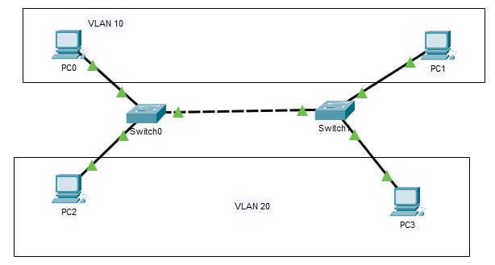

1. Configure the 4 PCs with below IP address details

|  |  |  |
| --- | --- | --- |
| **Device** | **IP address** | **Subnet Mask** |
| PC0 | 10.10.10.1 | 255.0.0.0 |
| PC1 | 10.10.10.2 | 255.0.0.0 |
| PC2 | 20.20.20.1 | 255.0.0.0 |
| PC3 | 20.20.20.2 | 255.0.0.0 |

1. Configure the two switches to handle the following VLANs

Name: Staff - VLAN Number 10

Name: Student - VLAN Number 20

Hint: You may need to configure trunk ports based on the requirements.

1. Switch ports 0/1-0/10 is allocated to VLAN 10 and 0/11-0/20 is allocated to VLAN 20. Last 4 ports are reserved for inter-device connections (Trunks).

* Access ports must be configured
* Trunk ports should be configured for full duplex mode

1. Once the configuration is done ping from each PC to each other PC and complete the below table

|  |  |  |
| --- | --- | --- |
| From PC | To PC | Outcome |
|  |  |  |
|  |  |  |
|  |  |  |
|  |  |  |
|  |  |  |
|  |  |  |
|  |  |  |

1. Analyze and explain the ping results